Topic 4: Materials

0.4 Specification notice:
In order to develop their practical skills, students should be encouraged to carry out a range of practical experiments related to this topic.
Mathematical skills that could be developed in this topic include determining the slope of a linear graph and calculating or estimating, by graphical methods as appropriate, the area between a curve and the x-axis and realising the physical significance of the area that has been determined.
This topic may be studied using applications that relate to materials, for example, spare-part surgery.

4.Q Exam questions

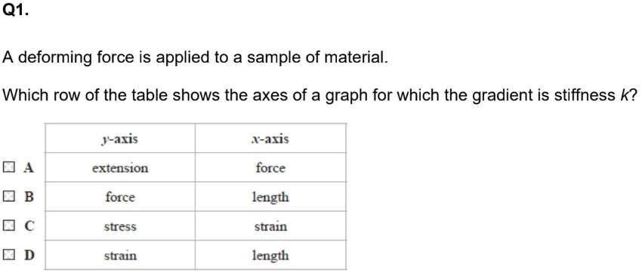  Which row of the table shows the axes of a graph for which the gradient is stiffness k? | 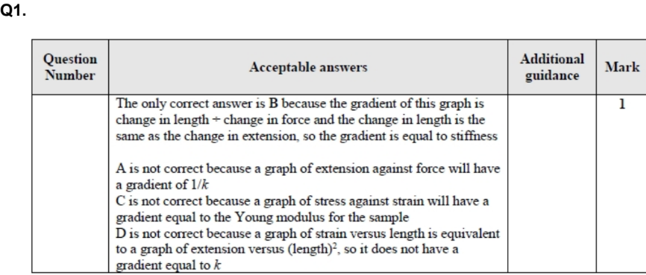  - B is correct

4.49 be able to use the equation density ⍴=m/v
Define density? And what are its unit? While you're at it, write the equation for density? | - The mass per unit volume  - g/cm³ or kg/m³  - ⍴ = m/v  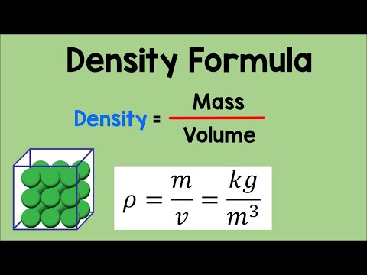
Identify the factors that affect the density of liquids and gases? | - Density is affected by the mass of each particle and the spacing between the particles  - Therefore gases are lower density than liquids as they have much larger inter-molecular spacing
How would you convert from mm³ to m³ | Divide by 1x10⁻⁹
How would you convert from g/cm³ to Kg/m³ | g/cm³ x 1000 = kg/m³
Volume of a sphere equation | V=4/3𝞹r³
Volume of a cylinder equation | V=𝞹r2h
Area of circle equation | A=𝞹r²

4.50 understand how to use the relationship upthrust = weight of fluid displaced
Define upthrust? | The upward force caused when a fluid is displaced
Define Archimedes Principle? | The upthrust is equal to the weight of the fluid displaced
State the condition that is required for an object to float in a liquid? | Upthrust = weight
What is the upthrust equation either variation? | - (U=mg) Upthrust = mass of fluid displaced times gravitational field strength  - (U=p_{f}Vg) Upthrust = density of fluid x volume of fluid x gravitational field strength  Think of p_{f}Vg looking like an owl and so you can refer to it as the owl equation
Draw the 2 different diagrams of the 3 forces acting on a bubble in a fluid for when it rises and falls? | 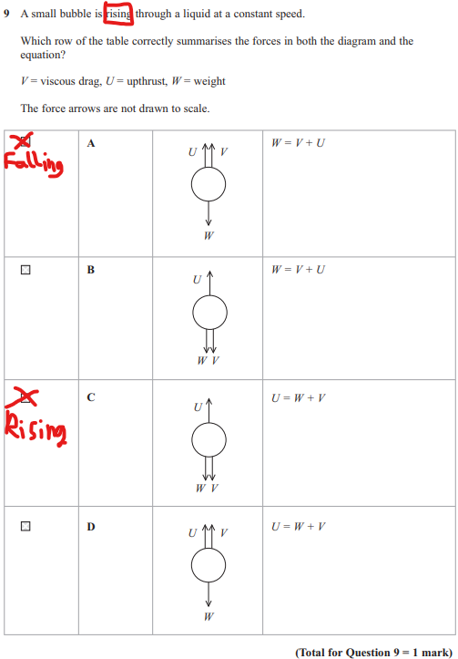

4.51 a. be able to use the equation for viscous drag (Stokes’ Law), F = 6πηrv. b. understand that this equation applies only to small spherical objects moving at low speeds with laminar flow (or in the absence of turbulent flow) and that viscosity is temperature dependent
Describe laminar flow 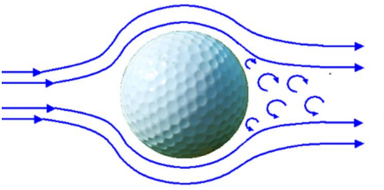 | - Occurs at low velocity only  - Streamlines never cross  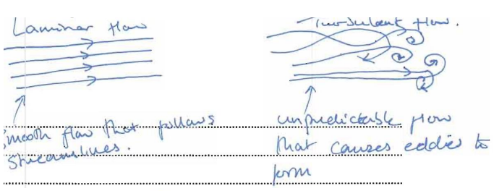
Define turbulent flow?  (The circle things not the straight line) | Where the streamlines cross and form eddies (area behind the ball chaotic)
Define viscosity and what are its units? | - Viscosity is how hard it is for a fluid to flow  - Pa s (pascal seconds)
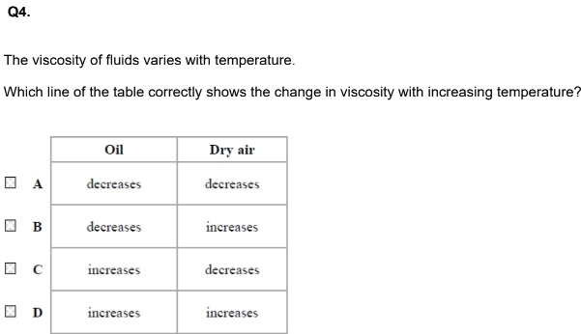Why does viscosity decrease at higher temperatures for liquids but increases with gases at a higher temperature & Answer this question: | - At higher temperatures particles in liquids move faster and hence viscosity is reduced as the drag force would be less at a given speed and so terminal velocity will be greater  - At higher temperatures, particles in gases collide more as they have a higher KE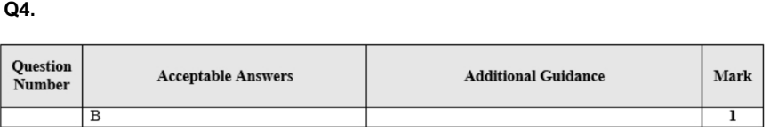  - B is answer
State the conditions required to apply Stokes’ law? (4) | - Low velocity  - Small object  - Spherical object  - Smooth object  - The flow is laminar
State stokes law and what each constant means in the viscous drag equation? n = η and pi = 𝝿 | - F=6η𝝿rv  - F = force of drag  - η = viscosity  - r = radius of sphere  - v = terminal velocity
What is the weight equation in terms of stokes law as the owl equation? | - W=p_{(s)}Vg  - p = density of solid (sphere)  Think of p_{s}Vg looking like an owl then you can refer to it as the owl equation
How would you derive terminal velocity from stoke’s law? p = density | - U=p_{(f)}Vg  - F_{d}=6η𝝿rv  - W=p_{(s)}Vg  - V = 4/3𝝿r³  - D+U = W  - D = W-U  - 6η𝝿rv = p_{(s)}Vg - p_{(f)}Vg  - 6η𝝿rv = Vg(p_{(s)}- p_{(f)})  - 6η𝝿rv = 4/3𝝿r³g (p_{(s)}- p_{(f)})  - v = 2r²g/9η (p_{(s)}- p_{(f)})  - v = 2g/9η (p_{(s)}- p_{(f)}) x r²  - With y=mx+c  - Where v = y, m = 2g/9η (p_{(s)}- p_{(f)}) and x = r²  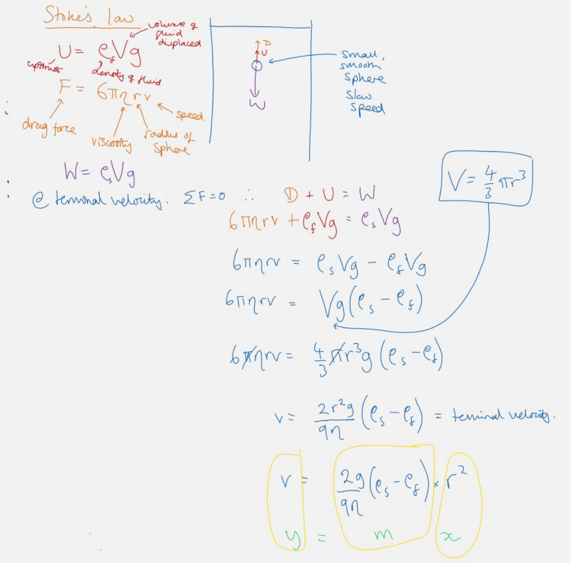

4.52 CORE PRACTICAL 4: Use a falling-ball method to determine the viscosity of a liquid.
State the measurements you would need to take to determine the viscosity of a liquid | - Diameter of the balls (Using a vernier calliper)

4.53 be able to use the Hooke’s law equation, ∆F = k∆x, where k is the stiffness of the object
State Hooke’s law and the conditions under which a material obeys Hooke’s law? | - Force is directly proportional to extension up to the limit of proportionality  - F=kΔx  - k = stiffness constant (spring’s constant)  - Δx = extension  The graph of force against extension of a spring obeying Hooke’s Law will have a line of constant gradient passing via the origin. These are two features
What is the equation for Hooke’s law in series and why? | - 1/k_{T} = 1/k₁ + 1/k₂  - There is a force of Mg pulling on both springs -> overall extension is double ( as there are two springs) -> the overall spring constant has to be k/2 -> the elastic strain energy would be 2E.  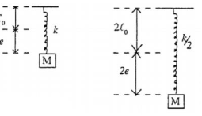  On the load-extension graph, you have a greater extension on the equivalent spring for less force so the line is shallower. You can think of this as a longe bungee rope stretching more than a shorter one.
How does Hooke’s Law work on springs in parallel and why? | - k_{T}=k₁+ k₂  - The same force of Mg is shared between both springs -> extension on each is ½ the original -> spring constant has to be 2k -> the elastic strain energy would be 0.5E  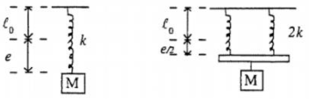  On the load-extension graph, you’re getting half the extension for the same force so the line is steeper. You can think of this as using muscle building equipment using multiple parallel springs, the more springs, the harder it is to compress (and hence stiffer)

4.54 understand how to use the relationships ● (tensile or compressive) stress = force/cross-sectional area ● (tensile or compressive) strain= change in length/original length ● Young modulus = stress/strain
Define stress? | The force per unit area
What is the equation for stress? And what is each quantity | - σ=F/A  - Stress = pascal (Pa | Nm⁻²)  - F = Newtons (N)  - A = Cross sectional Area (m²)  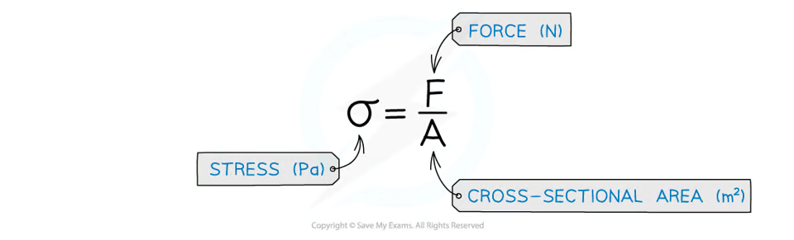
What is tensile stress ? | Forces acting away from each other causing tension so that the object will increase in length and stress=force/cross sectional area  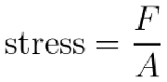  This differs from pressure in that an object under stress is pulled rather than pushed
What is compressive stress? | Forces acting towards each other causing compression so that the object will decrease in length and stress = force/ cross sectional area  This differs from pressure in that an object under stress is pulled rather than pushed
Define Strain? | The ratio of extension to original length  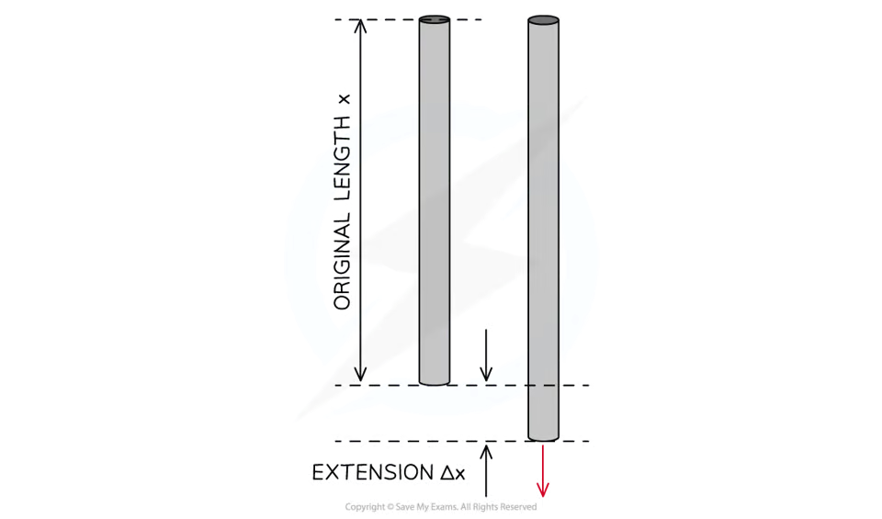
What are the 2 variations for the equation for the ratio of strain? | ε=Δx/x or ε=Δl/l  - Δx = extension  - Δl = change in length  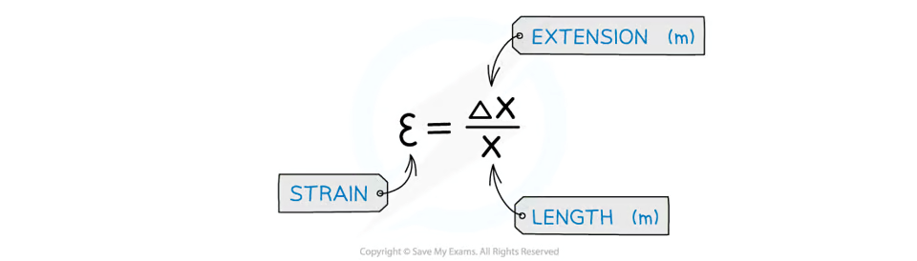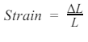
Describe tensile strain? e=ε | Forces acting away from each other causing tension so that the object will increase in length and strain = extension/original lengthl  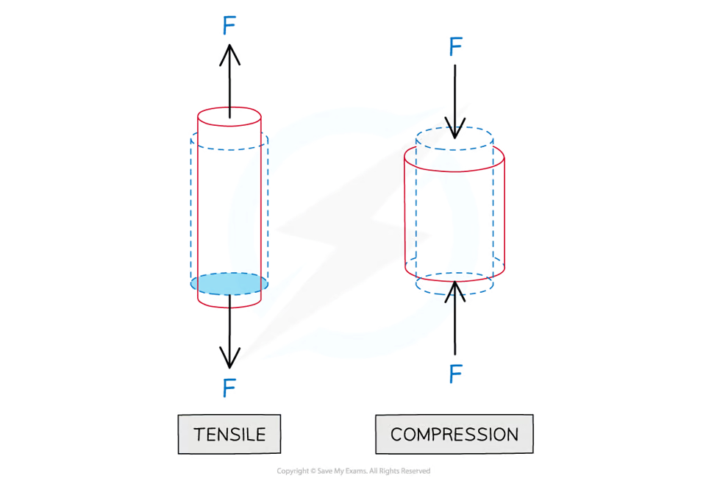
Describe compressive strain? e=ε | Forces acting towards each other causing compression so that the object will decrease in length and strain = extension/original lengthl
Define Young modulus? | The stiffness of the material given by the ratio of stress to strain  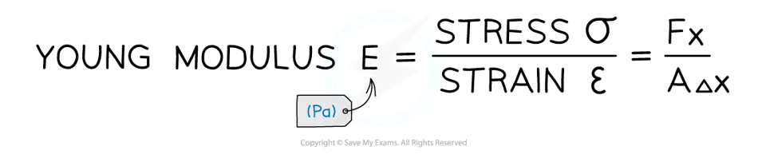
What is the equation for the young modulus? O=σ with its 3 variations | - E=σ/ε  - E=$\frac{F/A}{Δx/l}$  - E=$\frac{Fl}{AΔx}$
What is the equation for cross-sectional area? | A= $\frac{1}{4}πd^{2}$ or $π\left(\frac{d}{2}\right)$²  Often with questions like calculating resistivtity or stress they would give the diameter in mm don’t forget to convert to metres !!!

4.55 a. be able to draw and interpret force-extension and force-compression graphs b. understand the terms limit of proportionality, elastic limit, yield point, elastic deformation and plastic deformation and be able to apply them to these graphs
Draw a force-extension graph labelling: Hooke’s law, Elastic limit, Limit of proportionality (LOP), Elastic deformation, Plastic deformation, Yield point | 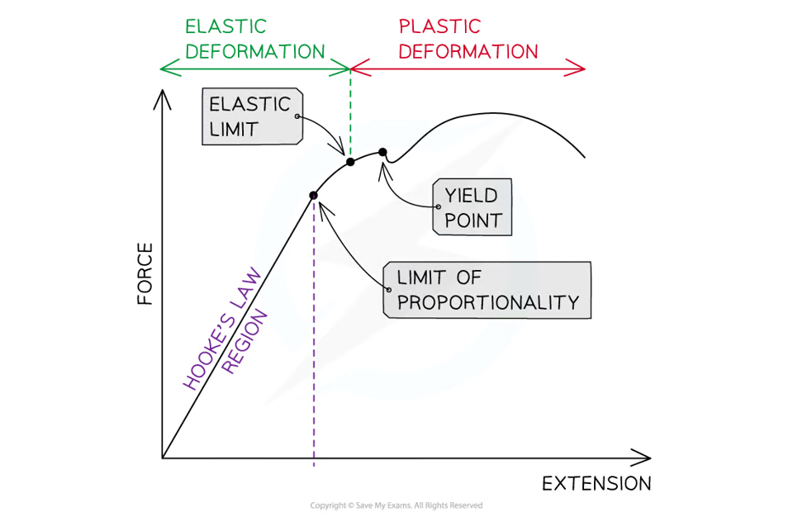
Define limit of proportionality?  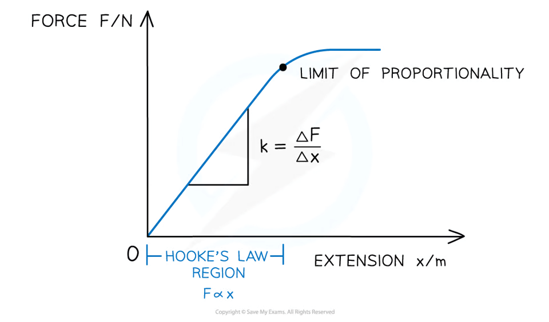 | The point beyond which hooke’s law is no longer true when stretching or compressing a material
Define elastic limit? | The point before which a material will return to its original length or shape when the deforming force is removed  This point is always after the limit of proportionality
Define yield point? | Is where the material continues to stretch even though no extra force is being applied to it
Define elastic deformation? | A change of shape where the material will return to its original shape when the load is removed
Define plastic deformation? | A change of shape where the material will not return to its original shape when the load is removed  It occurs after the yield point
What is plastic and elastic behaviour? | - Plastic behaviour - doesn't return to its original shape after forces removed  - Elastic behaviour - returns to its original shape after forces removed
Which row of the table shows the axes of a graph for which the gradient is stiffness k? | - B is correct

4.56 be able to draw and interpret tensile or compressive stress-strain graphs, and understand the term breaking stress

What is the ‘breaking stress’/’ultimate tensile stress’ and what can it represent?  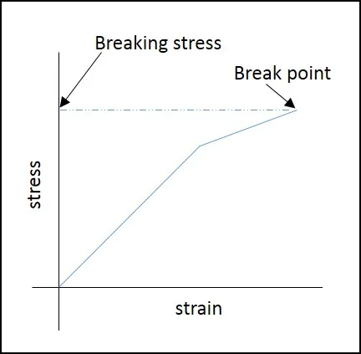 | - The maximum stress a material can hold before it breaks and represents the strength of a material  The maximum force per original cross-sectional area a wire is able to support until it breaks
Sketch and label the 4 points of the stress-strain graph for a ductile material (such as copper) | 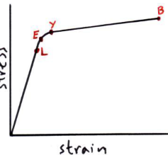  - L - limit of proportionality  - E - elastic limit  - Y - yield point (where a small increase in force leads to a large increase in length)  - B - breaking point/breaking stress
Sketch and describe the loading-unloading stress-strain graph of rubber | 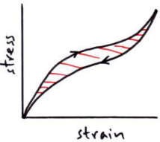  - The difference in area is the energy loss per unit volume due to internal friction  - This is called a hystersis loop  You know this shape because when pulling a rubber band, it starts off hard to pull, becomes easier, then becomes harder again
Sketch and describe the loading-unloading stress-strain graph for a metal wire obeying Hooke’s Law past the elastic limit | 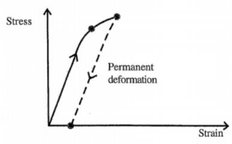  - Wire has been permanently stretched -> longer for a given load  - Area between is the energy required to permanently deform the wire as this energy isn’t recovered
Phrase to remember whether stress or strain comes first in the young modulus equation? | When you are stressed you show the strain (i.e. stress/strain)
What region on a stress-strain graph is hooke’s law obeyed?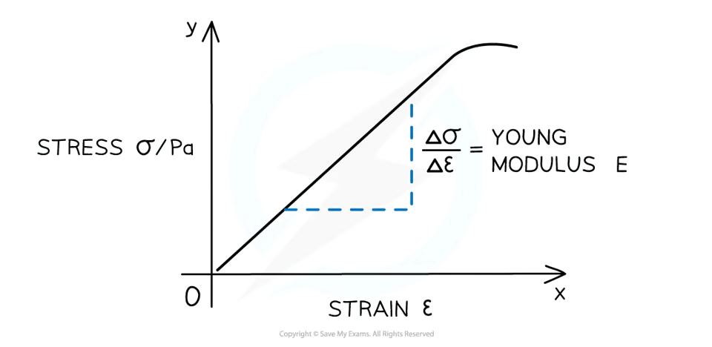 | The linear region
How and which region on a stress-strain graph can you ONLY calculate the young modulus from? | The gradient of a straight line of the linear region

4.57 CORE PRACTICAL 5: Determine the Young modulus of a material
State the measurements you would need to take to determine the young modulus of a length of wire? | - Diameter of wire (to find cross-sectional area)  - Mass of hanging masses (to find force)  - Original length  - New length (to find extension)
When is Hooke’s Law used and when is Young’s Modulus used? | - Hooke’s law is for specific devices (e.g., springs or some length of wire)  - Young’s modulus is used for materials (as its independent of dimension)

4.58 be able to calculate the elastic strain energy E_{el} in a deformed material sample, using the equation ∆E_{el} = 0.5F∆x, and from the area under the force-extension graph

The estimation of area and hence energy change for both linear and non-linear force-extension graphs is expected.
What does the area beneath a force-extension graph represent? | The work done on the material
Explain what is meant by hysteresis?  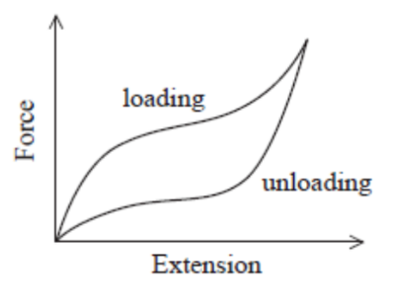 | - Work is done on the material when loading (= area under whole graph)  - Energy is released by the material during unloading (= area under unloading curve)  - At each extension there is more force on loading than there is on unloading  - Energy is transferred to the internal store of the material (thermal if elastic, thermal and work done permanently deforming the material if inelastic)
What are the 2 equations for elastic strain energy (elastic potentially energy)? | ∆E_{el} = 0.5F∆x  - And since Hooke’s law states that F=k∆x  ∆E_{el} = 0.5k(∆x)²
What is elastic strain energy (elastic potentially energy)? | The stored potential energy in an elastic object - all the work done in stretching it
What property does a strong material have? | Can withstand a large breaking stress before failure
What property does a stiff material have? | Large stress only produces a small strain  - Steep gradient
What property does a tough material have? | Requies a large amount of energy to cause fracture/failure
What property does a brittle material have? | High Young modulus  - No plastic region  - Dont stretch far beyond their elastic limit. They break  - Requires low work done per unit volume before it breaks  - Will undergo very little/no plastic deformation before failure  - Where a material undergoes little to no plastic deformation before fracturing (break apart) at a low strain
What property does a ductile material have? | Large plastic region  - It can be deformed plastically  - Able to be drawn into a wire  - Can undergo a large amount of plastic deformation before facturing  - Large increase in strain for small increase in stress
What property does a plastic material have? | Where a material will experience a large amount of extension as the load is increased
What property does a malleable material have? | - The materials stretch far  - Able to be hammered into shape  Large plastic region  - It can be deformed plastically  - Able to be drawn into a wire  - Can undergo a large amount of plastic deformation before facturing  - Large increase in strain for small increase in stress
Label the graph below identifying the brittle material, the plastic material, the ductile material and the strong (but not ductile material?  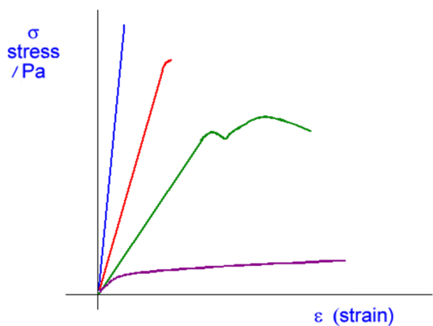 | - Blue (top) = brittle  - Red (second) = strong  - Green (third) = ductile  - Purple (bottom) = plastic
What is the difference between a material being malleable or ductile? | - Ductility is the ability of a material to plastically deform without breaking when tensile stress is applied to it  - Malleability is the ability of a material to plastically deform without breaking under compressive stress rather than tensile stress
Properties of materials | Strong:  can withstand large stress before failure/breaking  ii. Stiff:  large stress only produces a small strain  iii. Tough:  Requires a large amount of energy to cause fracture/failure  iv. Brittle:  Requires very little energy to cause fracture/failure. Will undergo very little plastic  deformation before failure.  v. Elastic:  Returns to its original shape when the force has been removed  vi. Hard:  Able to withstand being scratched (not on spec)  vii. Ductile:  Able to be drawn into a wire  viii. Malleable:  Able to be hammered into shape

